AWS Challenge
Launched the Amazon Linux 2 EC2 Instance with the default Security Group.
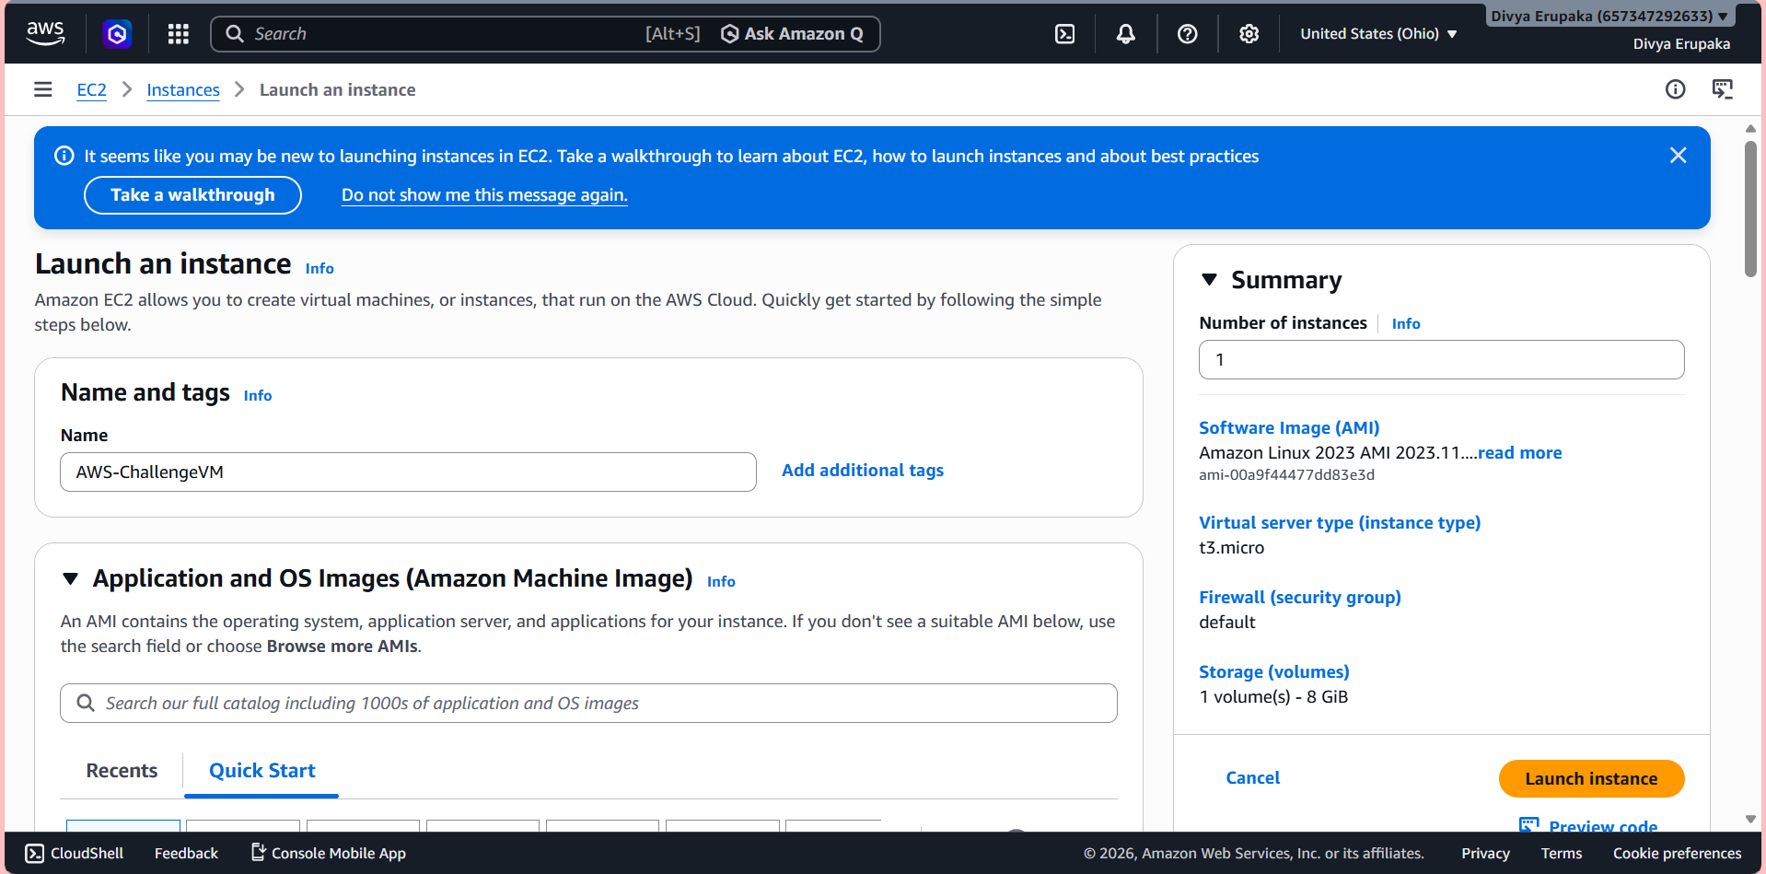
Successful Launch.
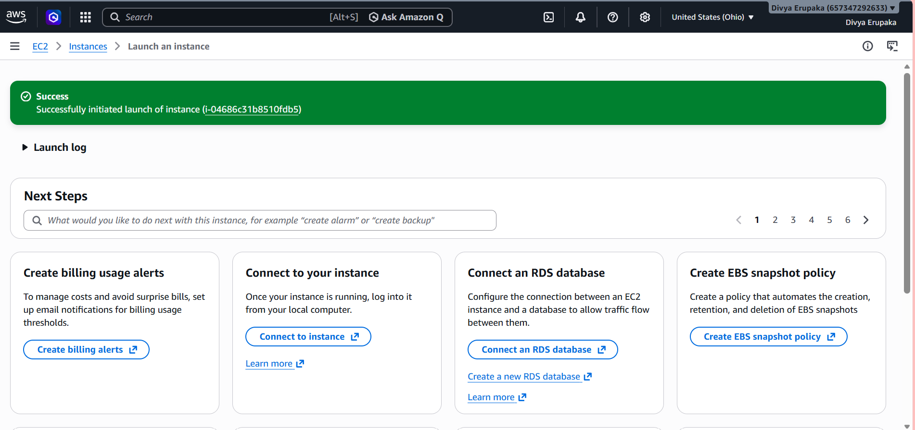
Connected to EC2 instance
ssh -i your-key.pem ec2-user@PUBLIC-IP using this command.
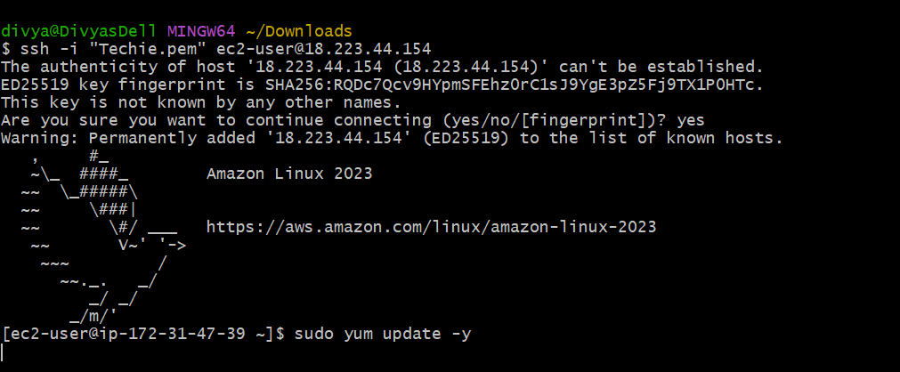
Update Packages using sudo yum update -y
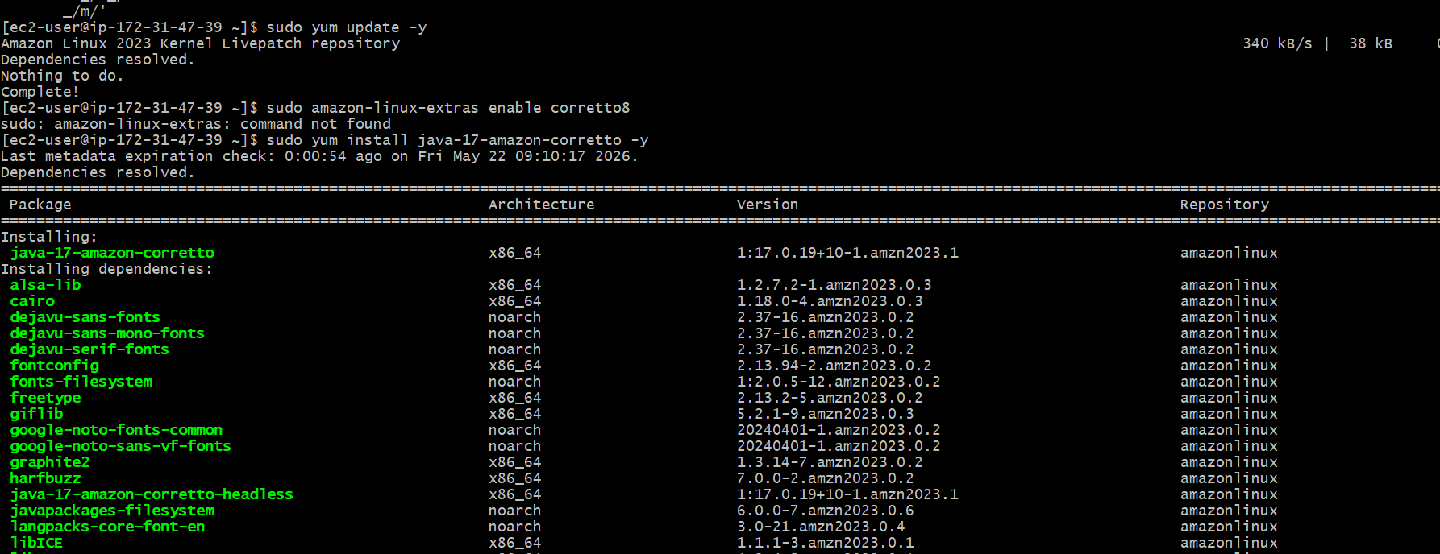
Installation of Java Required for Jenkins and Tomcat.
Commands used – sudo yum install java-17-amazon-corretto -y
To verify Java installation – java -version
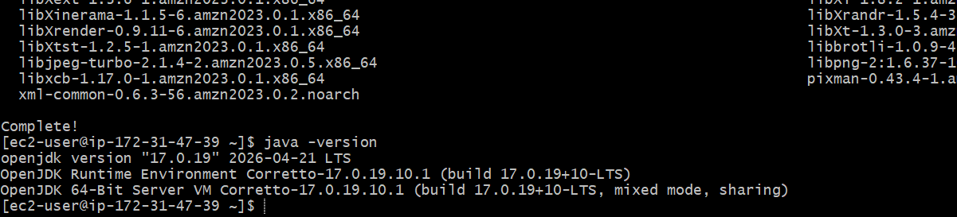
Install Docker
To install Docker Run Command --- sudo yum install docker -y
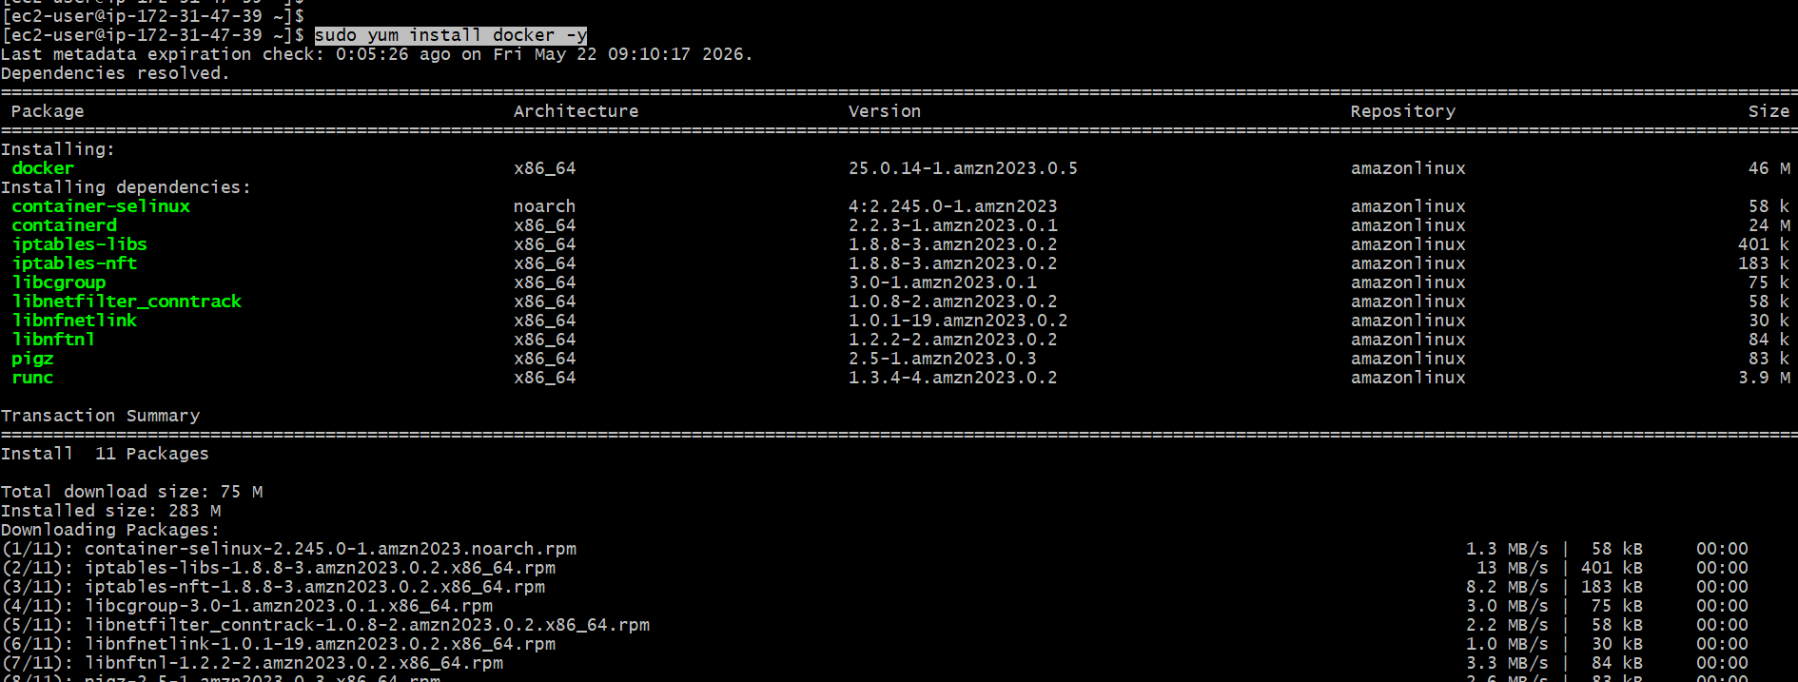
Next To Start Docker Service: sudo systemctl start docker
To enable Docker at boot: sudo systemctl enable docker
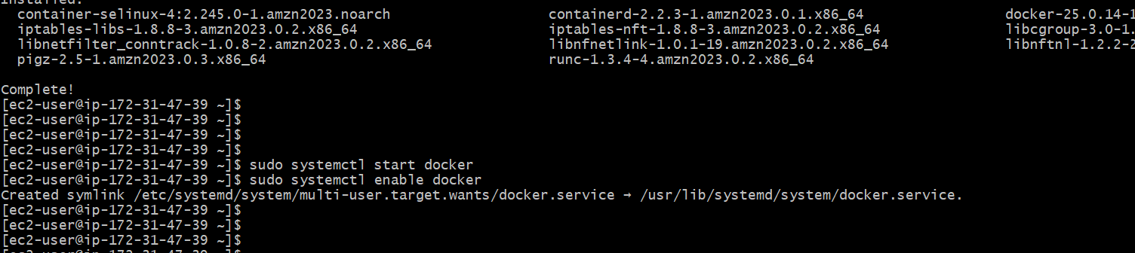
To Verify Docker Service Status: sudo systemctl status docker
Expected output should contain: active (running)
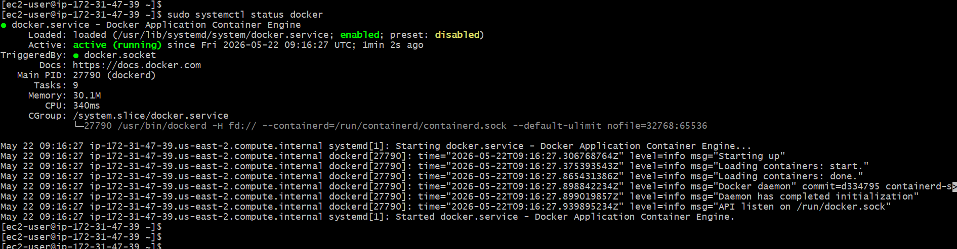
To Check Docker Version: docker –version
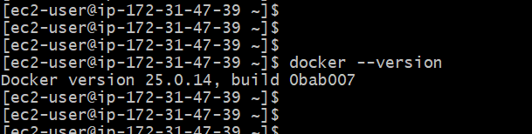
To Verify Docker Installation: docker run hello-world
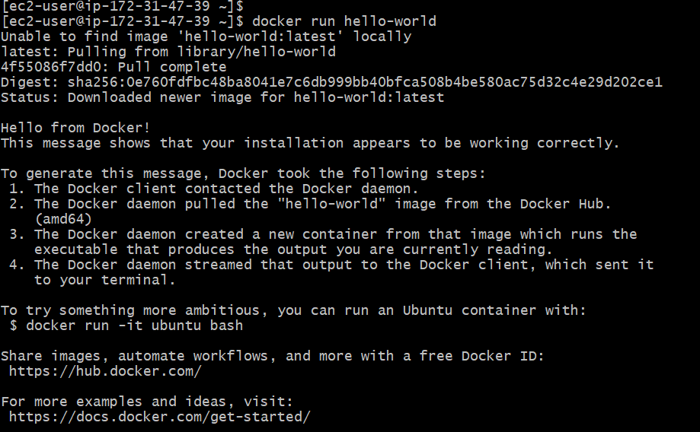
Install Jenkins
To install Jenkins, we need to update system packages, then install Java with sudo yum install java-17-amazon-corretto -y, which I already did above.
Next Step, we need to add Jenkins Repository:
sudo wget -O /etc/yum.repos.d/jenkins.repo \https://pkg.jenkins.io/redhat-stable/jenkins.repo
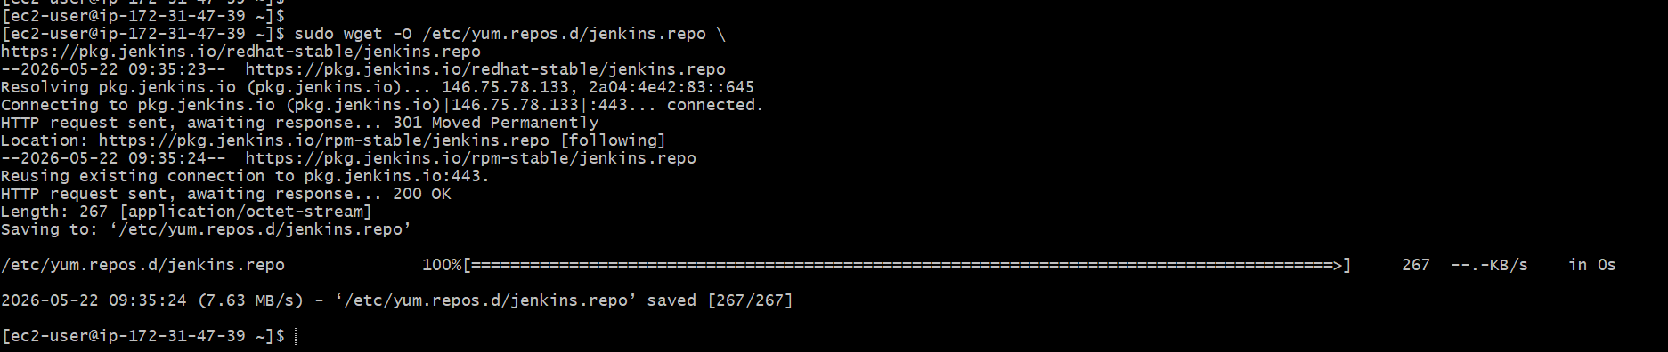
Next Import Jenkins Key: sudo rpm --import https://pkg.jenkins.io/redhat-stable/jenkins.io-2023.key
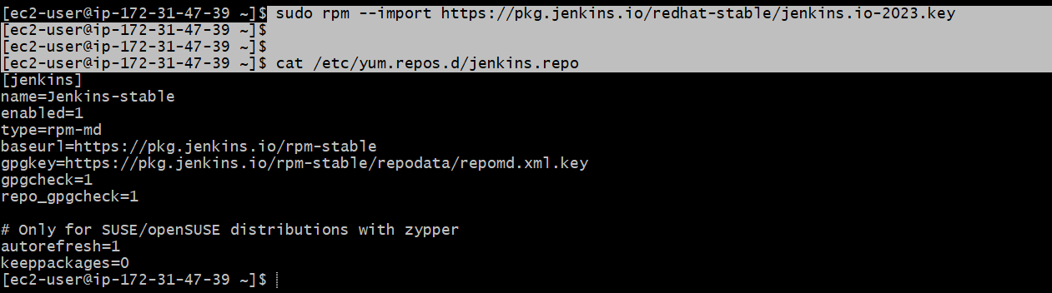
To Install Jenkins: sudo yum install jenkins -y
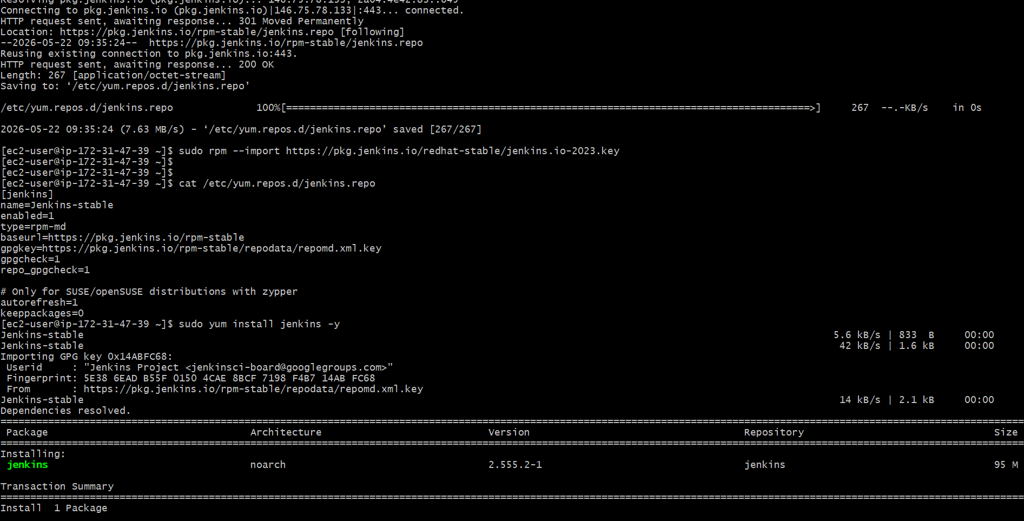
Next To Reload Systemd: sudo systemctl daemon-reload
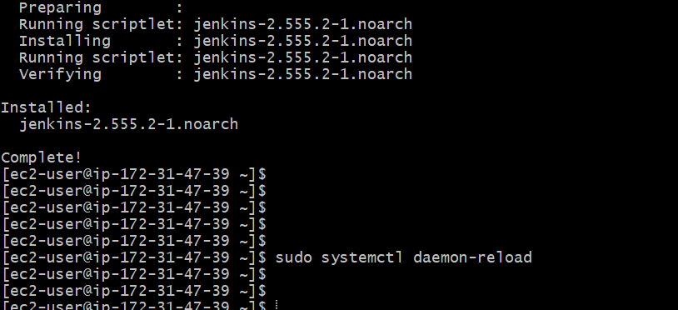
To Start Jenkins Service: sudo systemctl start Jenkins
and then Check the status: sudo systemctl status Jenkins
EXPECTED RESULT: active (running)
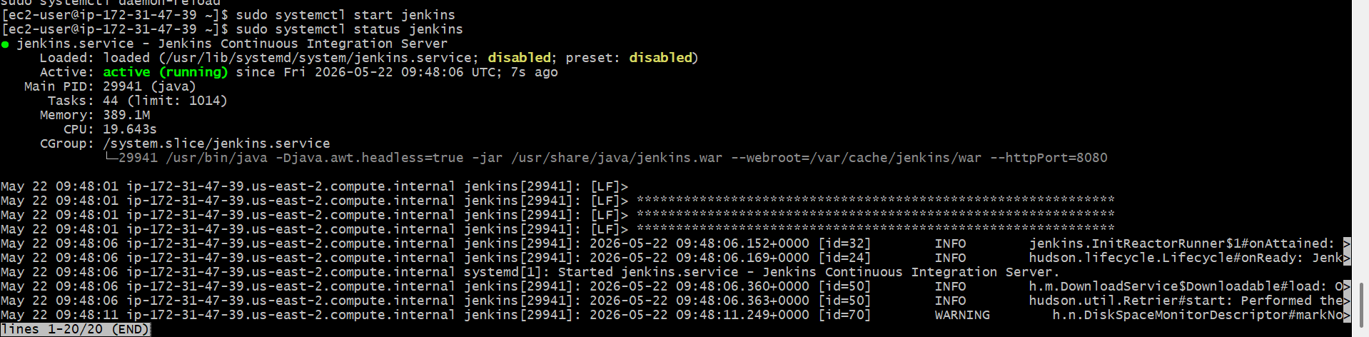
To verify Jenkins installation, open Jenkins in the browser
Go to: http://18:223:44:154:8080
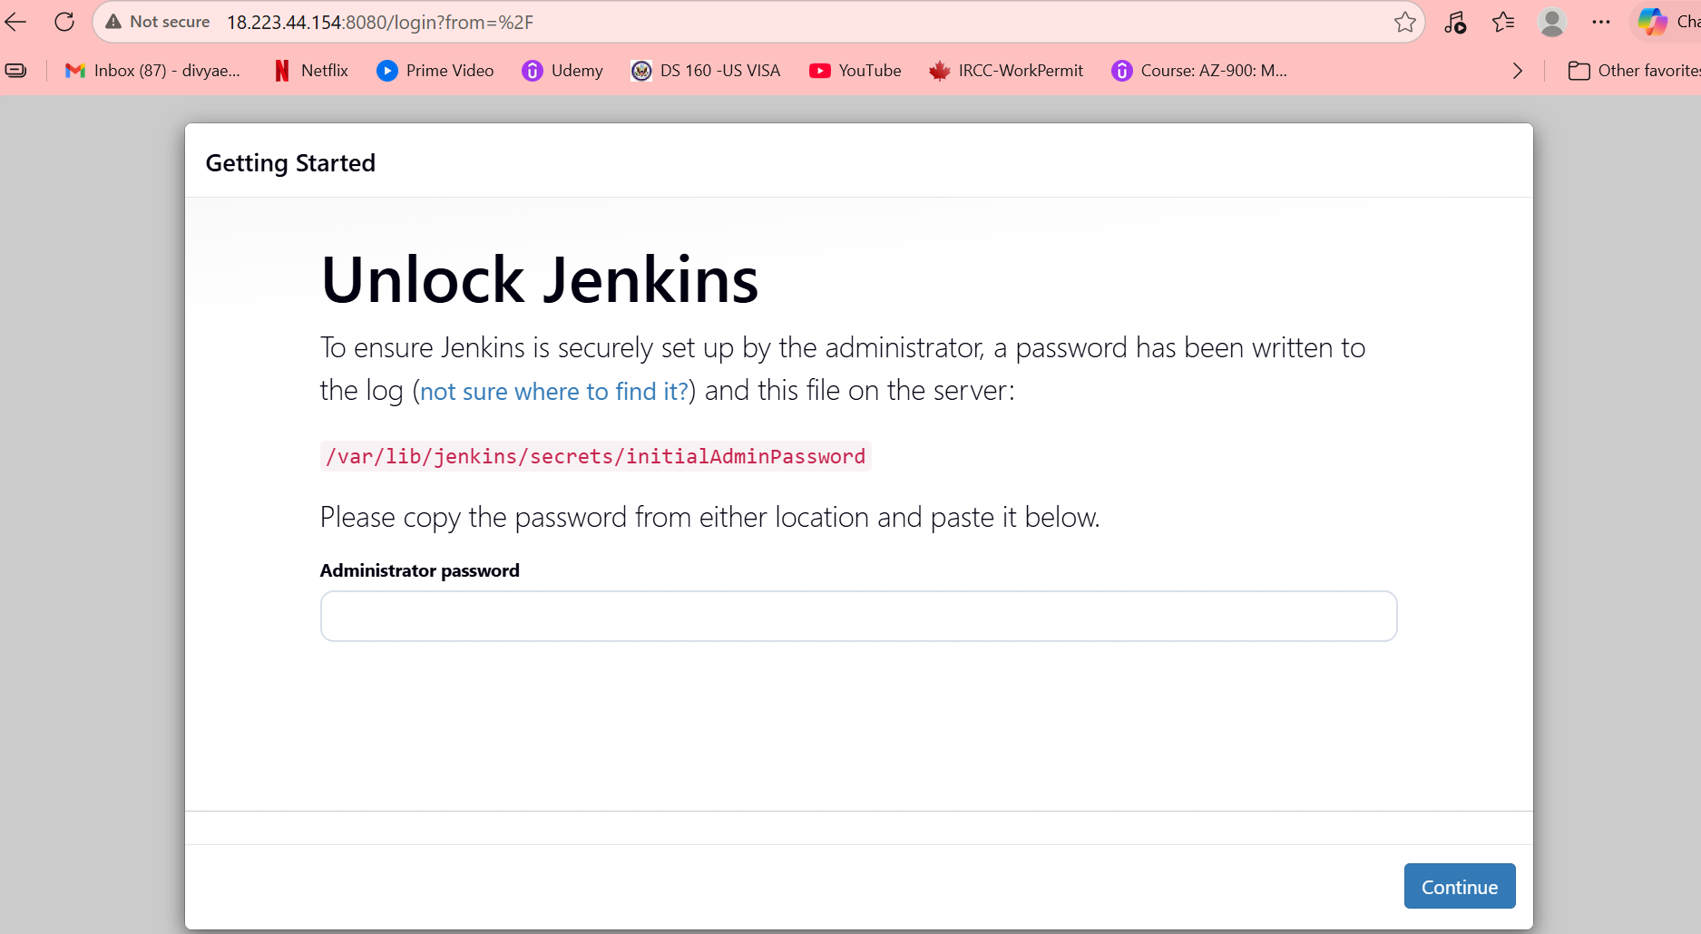
Install Apache Httpd
To Install Apache Run command: sudo yum install httpd -y
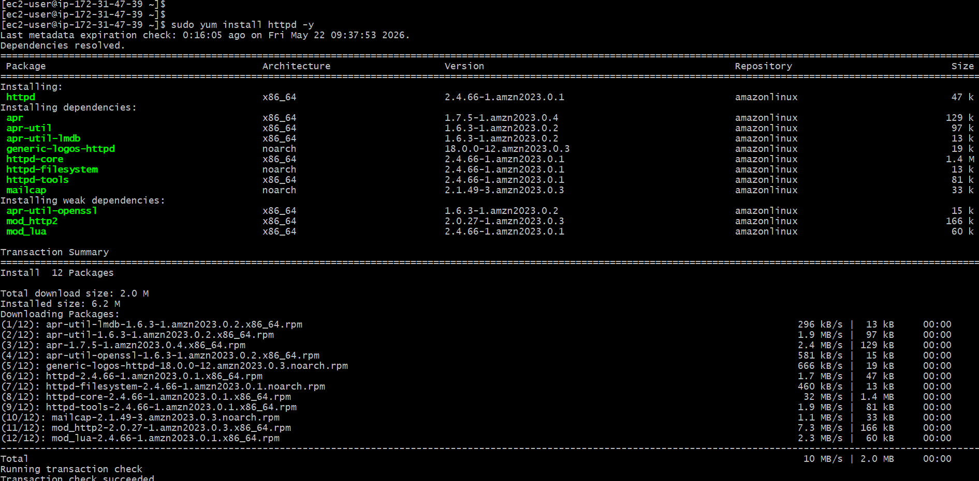
To start Apache Service: sudo systemctl start httpd
and To enable Apache service at boot: sudo systemctl enable httpd
To Check Apache status: sudo systemctl status httpd
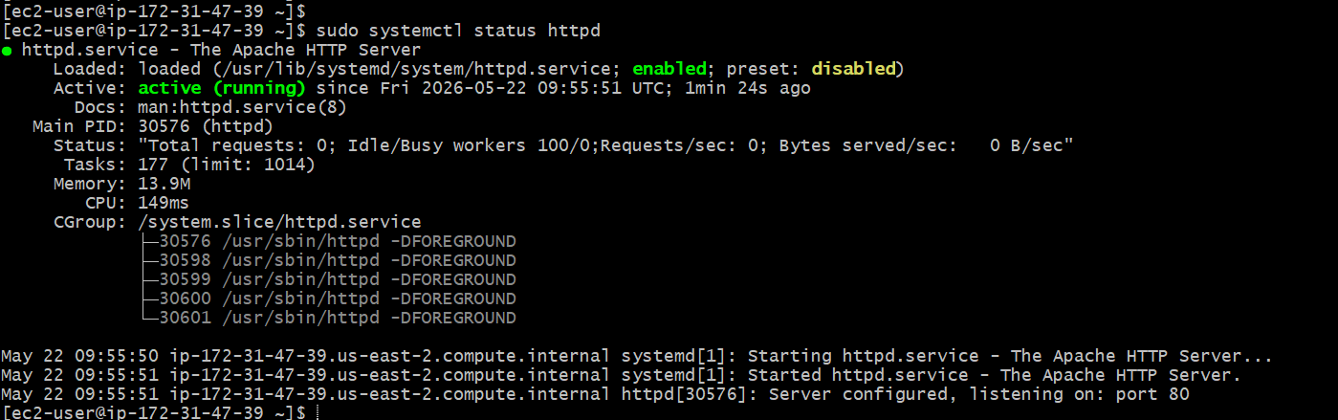
Open Apache in browser: http://18.223.44.154:80
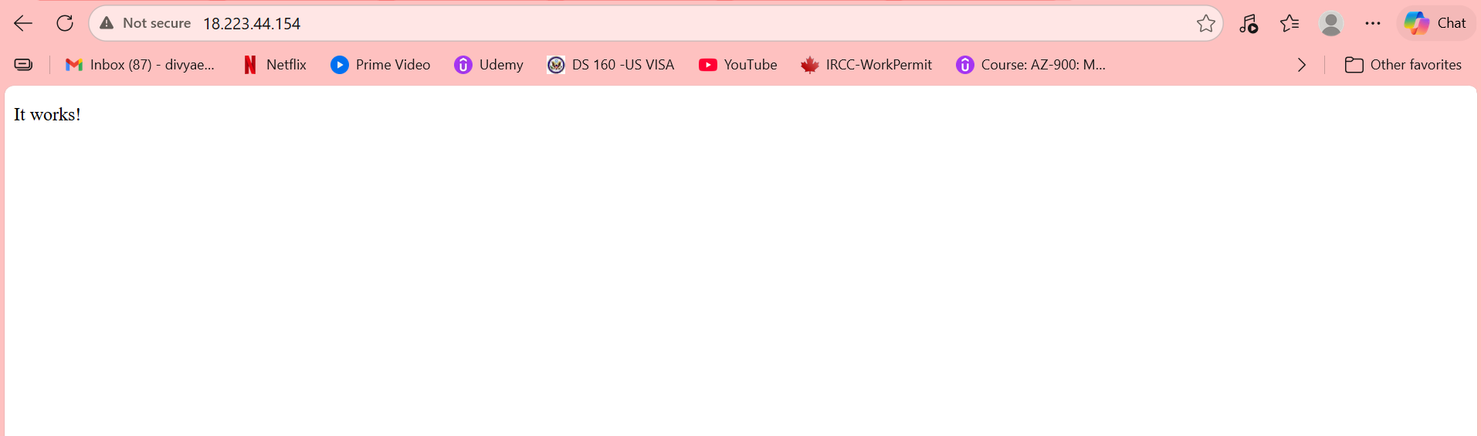
Install Nginx
Update packages: sudo yum update -y
To install nginx, run the command: sudo yum install nginx -y
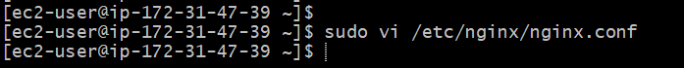
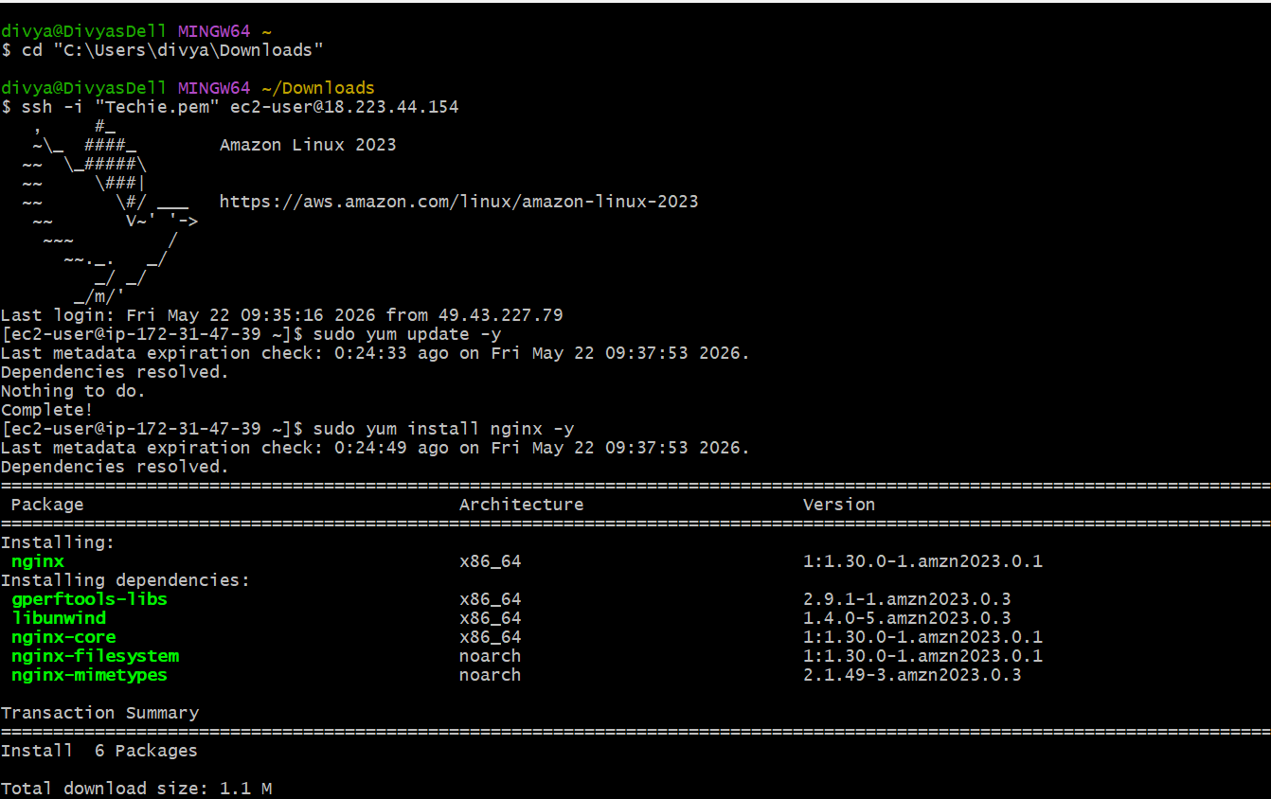
As Port 80 is already used by Apache, I have configured Nginx to run on Port 81.
The sudo vi /etc/nginx/nginx.conf command is used to customize the port.
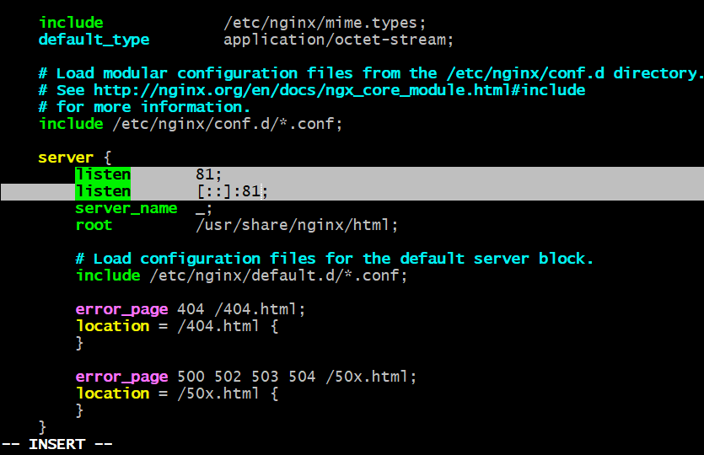
Now To start the nginx service: sudo systemctl start nginx
To enable the service: sudo systemctl enable nginx
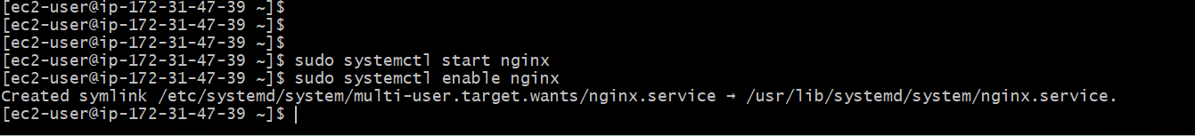
To check the status of nginx service: sudo systemctl status nginx
Expected output: Active: active (running)
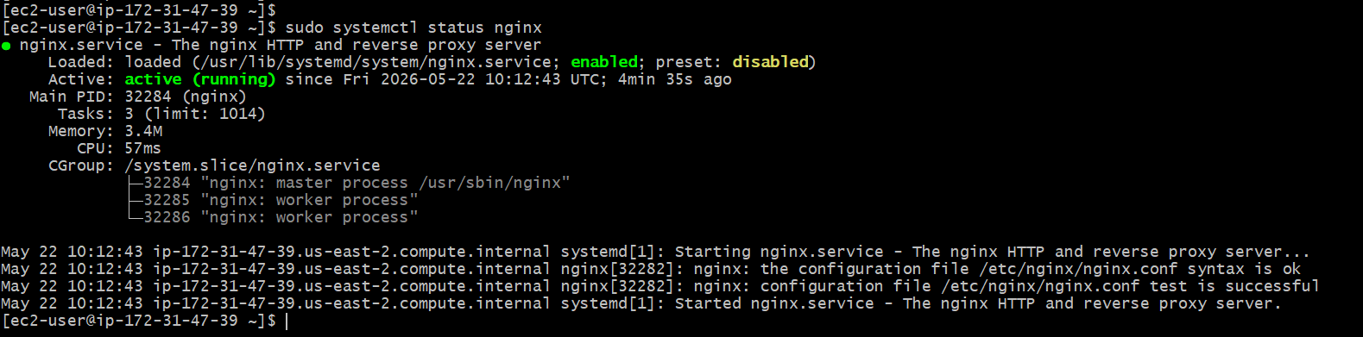
Open Nginx in the browser: Default Nginx runs on port 80, but is customized to run on port 81.
http://18.223.44.154:81
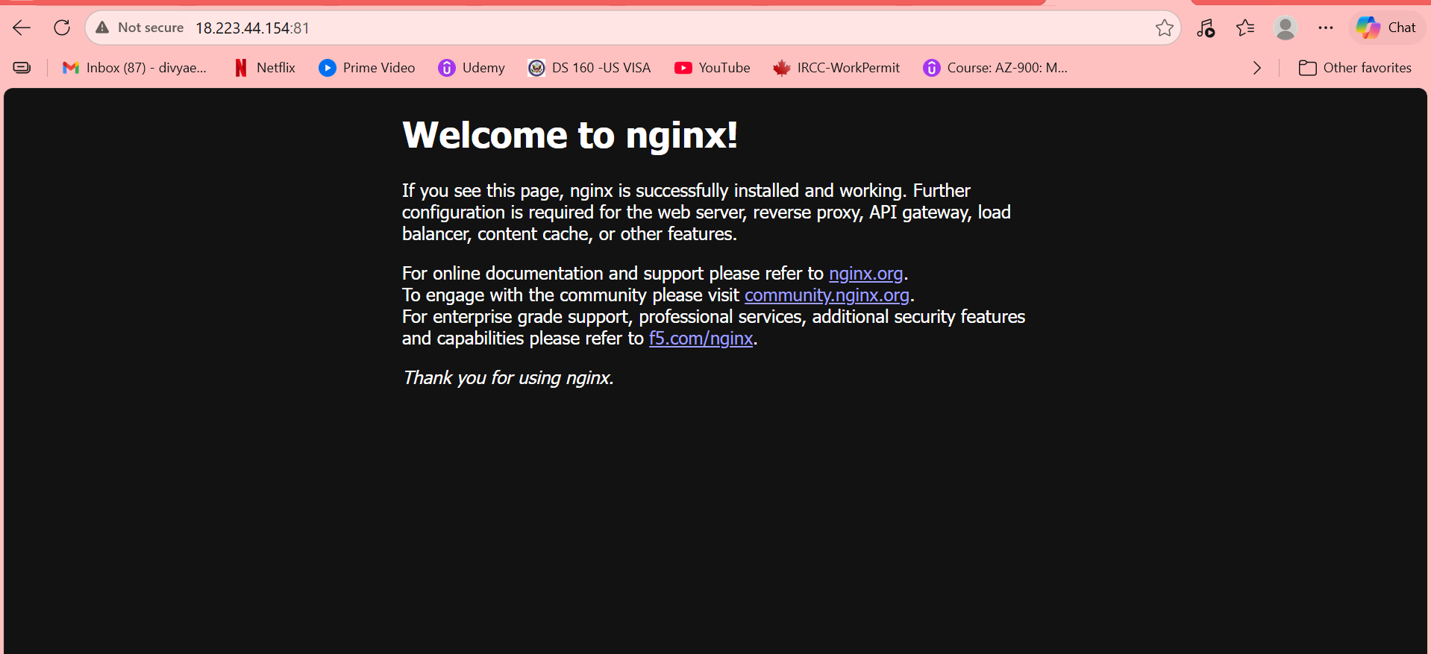
Install Apache Tomcat
First, change the directory to /opt: cd /opt
To Download Tomcat: wget https://archive.apache.org/dist/tomcat/tomcat-9/v9.0.96/bin/apache-tomcat-9.0.96.tar.gz
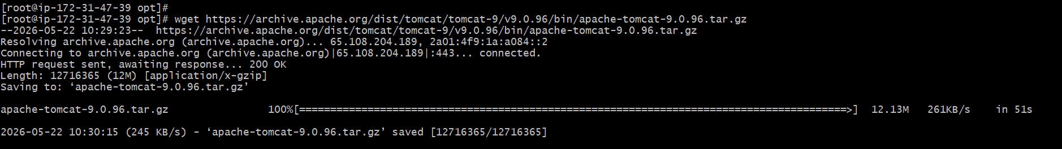
To Extract it: tar -xvzf apache-tomcat-9.0.96.tar.gz
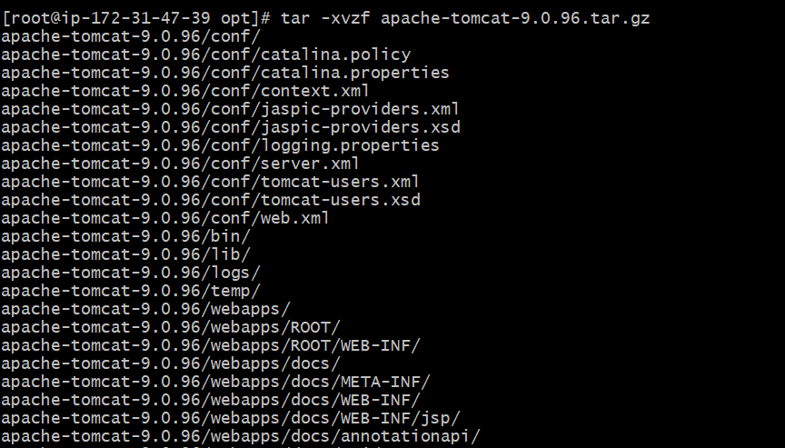
To Rename the folder: mv apache-tomcat-9.0.96 tomcat
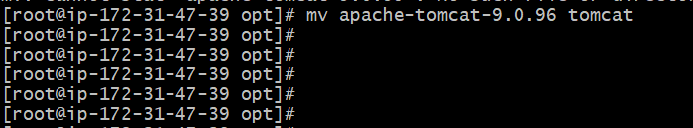
To move into Tomcat’s binary (execution) folder: cd /opt/tomcat/bin
To give permission to all .sh files to be executable: chmod +x *.sh
To start the Apache Tomcat server: ./startup.sh
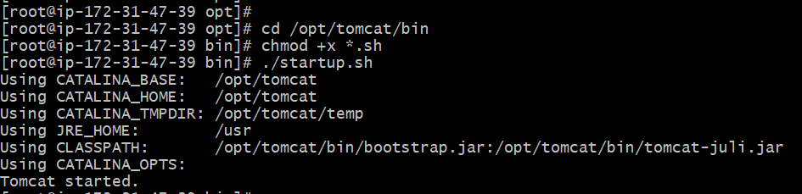
As the port 8080 is used and run by Jenkins, now I customized the port of Tomcat to 8082 in the file path
vi /opt/tomcat/conf/server.xml
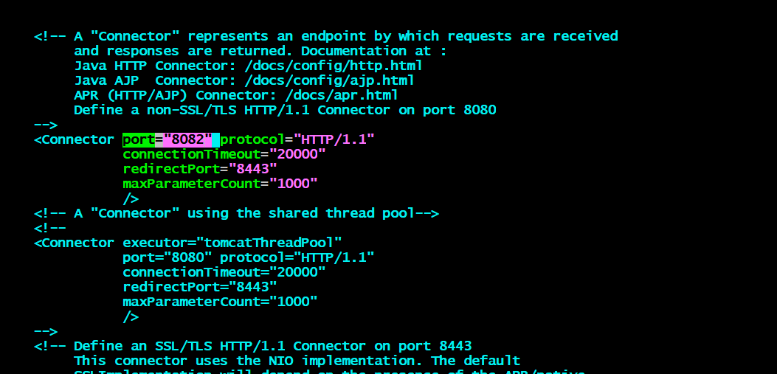
As we updated the port need to restart Tomcat using:
/opt/tomcat/bin/shutdown.sh
/opt/tomcat/bin/startup.sh
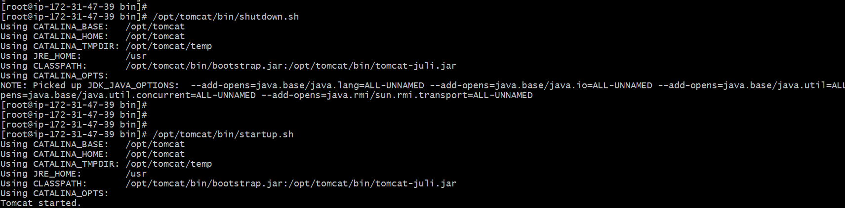
To Verify New Port: netstat -tulnp | grep 8082
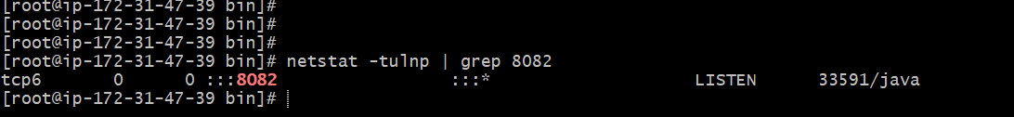
To open in the browser
Now access: http://18.223.44.154:8082
